**Adventure Works Sales Report**

**Background:**

The Sample Data Set of AdventureWorks is used here for analysis. The sales data from 2012 to 2015 are stored here in several tables.

|  |  |
| --- | --- |
| Fact Table | Dimension Table |
| Fact Sales | Customer  Date  Product  Product Category  Product Sub Category  States_Territory |

Chapter 1

First of all, the unnecessary columns (French Spanis etc.) are removed in Power Query. Duplicate rows from each Dimension Table are also removed.

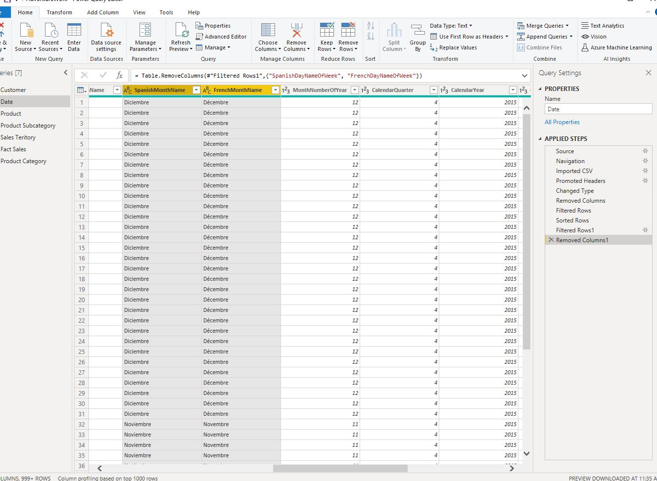

Chapter 2

The relationship between the fact and the dimension tables are then established. Fundamentally we develop a “Star Schema”. But this is not a pure Star Schema because here a portion of “Snowflake schema” was developed amount Fact Sales>Product>Product>Sub Category>Product Category.

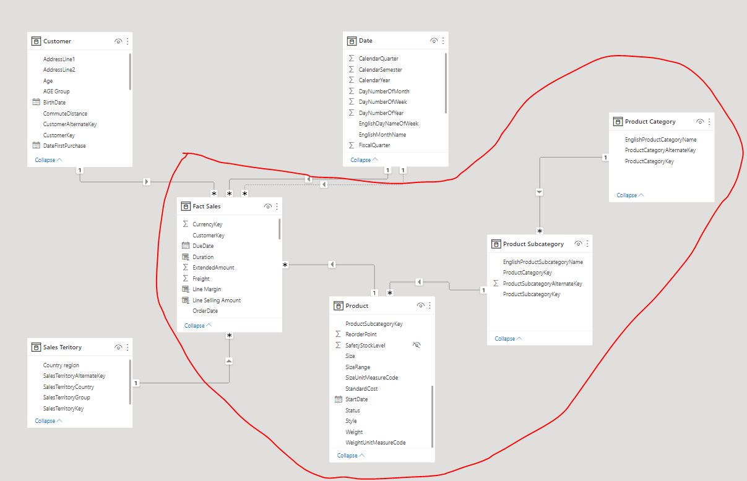 Chapter 3

1. In June 2014 and the margin was 0.81 million. 2014 accounted for 56.11% of Dynamic Total Sale.
2. Dynamic Total Sale for Yellow started trending up on December 2013, rising by 17.95% (91,070.71) in 6 months.
3. Dramatically Dynamic Total Sale of red colored product is decreased by 61.31% from June 2012 to July 2012 in just 1 month. Another drop down was held in between June 2013 to July 2013 by 63.39%.
4. USA and Australia were two big markets for the company. I think weather was a fact there. Total sales amount in USA was 9.39 million. The most interesting thing is the sales percentage is 60.90% in the South West region of USA.
5. Bike was the top product category. Road Bikes and Mountain Bikes were very popular. After May 2013 sales of Mountain Bikes started getting higher than Road Bikes. Mountain-200 was the highest selling bike.